

**Contact**

**Send you Cv’s to** [**job@mazco.com.sa**](mailto:job@mazco.com.sa)

**Or**

**Post Box: 2486, Dammam 31451,**

**KINGDOM OF SAUDI ARABIA.**

**Tell: +966 3 8260080 EXT: 31**

**Fax : +966 3 8266618**

**Website::**[**www.mazco.com.sa**](http://www.mazco.com.sa)

[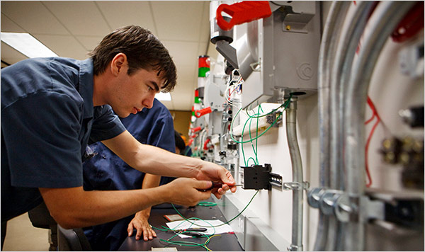](http://www.google.com.sa/url?sa=i&rct=j&q=&esrc=s&frm=1&source=images&cd=&cad=rja&docid=hijCBqLX7MoLMM&tbnid=770772PV9WxD6M:&ved=0CAUQjRw&url=http://www.nytimes.com/2009/04/26/jobs/26vocational.html&ei=oqlFUbDTMsKlO5LpgZAN&psig=AFQjCNF2gYRbTB6id2P317FZt4kg0BtQLQ&ust=1363606279283935)

**JOB DESCRIPTION**

Electrical technician shall

* Work with electrical system operation & maintenance (switchgears UPS, DC chargers, breakers. transformers, motors, CP, electrical control system. Light system, etc.
* Thorough understanding with practical experience in Implementation of techniques used in maintenance.
* Read the electrical drawings and its legend.
* Perform PM/CM activities.
* Use all measurements and testing tools.
* Applying electrical system troubleshooting/Tracing.
* Provide accurate written electrical technical reports.
* Doing any electrical Job as per technical instruction
* Perform all kinds of electrical Jobs within safely manner.

**QUALIFICATION**

* Diploma in Electrical Engineering
* Minimum experience of 5 years in the field
* Good communication skill
* Awareness of safety rules
* Analytical skill and organizational commitment

Electrical technician